E-Project
(Sports Info)

Zaid Iftikhar: ( 1067872 )
Zohaib Kabir: ( 1051954 )



Project Instructor:
Sir Imdad

Project Certification

This is to certify that,
Zaid Iftikhar : ( 1067872 )
Zohaib Kabir : ( 1051954 )

Has successfully designed & developed
Sports Info
Submitted By:
Zaid Iftikhar : ( 1067872 )
Zohaib Kabir: ( 1051954 )
Date of Submission:
9 January 2018
Authorized Signature: Sir Imdad

ACKNOWLEDGEMENT:
Praise is to Almighty Allah who taught us that we knew not. All thanks to our Omnipotent Lord, for providing us with opportunity and ability to commence, explore and eventually complete the report of the project.
We take this special occasion to thanks our parents. We dedicate this work to our parents, Teachers & Faculty. It would have been simply impossible to start continue and Complete without the support of our parents who, unconditionally provided the resources to us.
We are extremely indebted to our beloved sir Mr. Imdad for his precious time, valuable ideas and above all an untiring helping hand. Sir, thank you so much.
We are also thankful to our Faculty Member for their valuable and moral support.
Thank You.

TABLE OF CONTENTS
Contents
PROBLEM STATEMENT 5
Introduction 5
HARDWARE/ SOFTWARE REQUIREMENTS 5
Hardware 5
Software 5
SUBMISSION CHECK LIST 6
SCREEN SHOTS 7
Home Page 7
Gallery Page 8
About Page 9
Contact Page 10

PROBLEM STATEMENT

Introduction
Infocom is a multi national company that builds informative sites. i.e. CellInfo.com site gives all the information about cell phones, LibertyElectronics.com gives information about various electronics products and so on. Now the company has decided to develop a site sportsinfo.com where the user will get information related to sports. The developers in the company are currently working on many other projects because of which development of the sportsinfo.com is getting delayed. Hence the company wants you to develop the site for them.

HARDWARE/ SOFTWARE REQUIREMENTS

Hardware
- A minimum computer system that will help you access all the tools in the courses is a Pentium 166 or better
- 128 Megabytes of RAM or better

Software
- Notepad/HTML editor
- Dreamweaver / Javascript
- IE 5.0/ Netscape 6.0

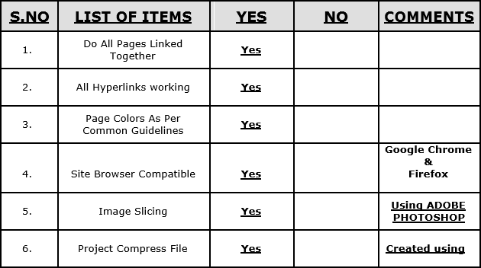
SUBMISSION CHECK LIST

SCREEN SHOTS

Home Page
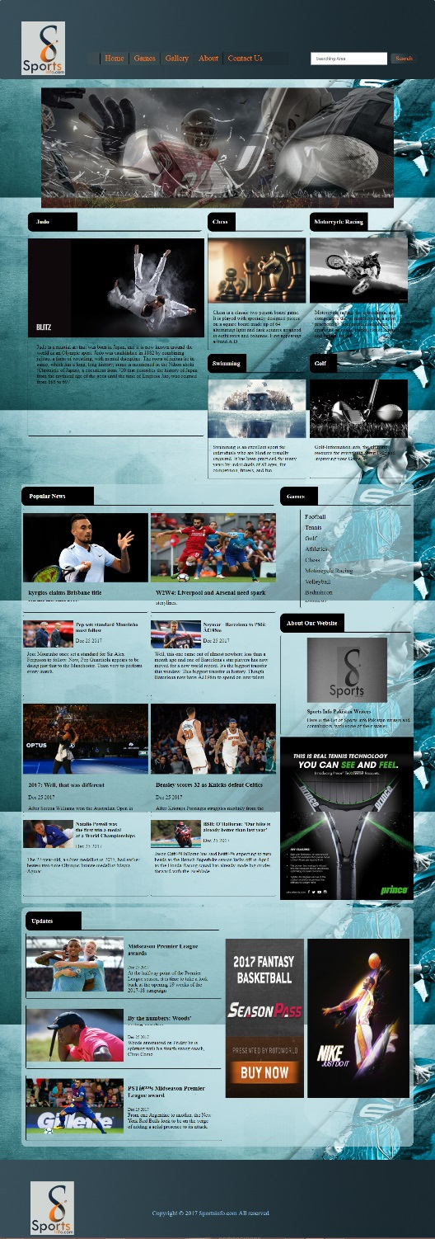

Gallery Page


About Page


Contact Page

